EXAMPLES OF WEBSITES TO PICK IDEAS FROM:
https://www.toyota.co.ug/

- Could you spread out the logos next to the FX Logo?
- We will have the inquiry form display on the home page and we are changing all the images in the homepage to those below. They will be motion images displaying at the background of the inquiry form on the homepage.
- We will discuss and decide whether it is best for registration on our page for one to inquire/order should be made optional or compulsory. If we decide that it be compulsory then ‘’Register’’ should appear first when customer clicks ‘’Inquire/Order’’.
- Registration on the page should be set out in a way that allows the customer to fill in his/her details and the details of the vehicles they have say vehicle 1 with its details, then vehicle 2, 3, etc. So when they want to inquire/order for parts they just click the vehicle for which they need parts and the details of the vehicle will automatically appear on their inquiry. There also has to be a way we will design for instances when the customer is inquiring/ordering for parts for more than one vehicle.
- Under vehicle details.
Check out: https://www.tc-v.com/
Use the lists that display under Makes: Toyota, Nissan, Mitsubishi, Subaru, Lexus, Kia, Honda, Isuzu, Mercedes Benz, Suzuki – in that order.
For each MAKE you activate, the MODELS dropdown automatically populates. So you will add all the models under each make accordingly.
Place ‘’Optional’’ in the Year of Manufacture box. But Make, Model and VIN/Chassis/Frame are compulsory field.
- When one clicks the quantity box on inquiry, the next line appears. Replace this with ‘’Add Part’’ which the customer clicks to add the next line of parts.
- Replace ‘’if available’’ with ‘’Optional’’ in the space for Part Number.
- Products – need to re-upload under each of the categories. We will need more and I will send them in due course.
- Will the images come out clearly? You could search clearer images in case of any I have provided below that does not come out well.
- Place the vehicle models i.e. PREMIO, WISH etc. on the real respective images.
- For vehicle photos that have number plates, do not let the registration numbers appear.
- Do you still have the data I shared for the Management information system for all the business aspects: Sales, Purchases, Stock, invoicing etc? We need to incorporate this too. We can benchmark with Quickbooks, URA EFRIS etc. Access for only authorized users.
Like we had discussed, I should be able to access the MIS online anywhere.
- Social media Platforms: Facebook, Twitter, YouTube, WhatsApp(like those of UMEME etc), and any other.

WEBSITE IMAGES:
- Will the images come out clearly?
- Descriptions can be put below or above the photos – whichever will look fancier.
- For vehicle photos that have number plates, do not let the registration numbers appear.

- Genuine Vehicle Parts


Service Parts
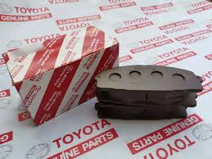
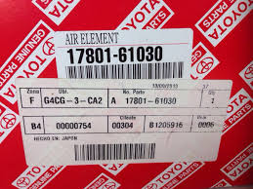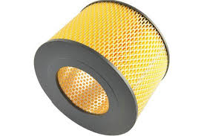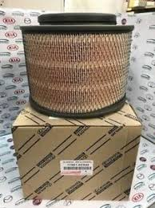
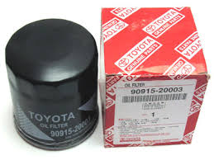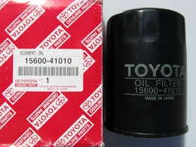

Repair Parts
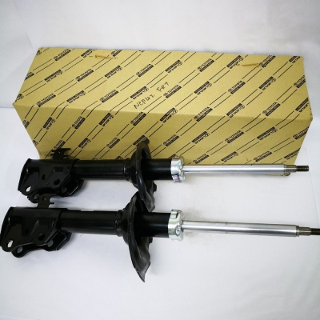

- GENUINE PARTS FOR:
HARRIER
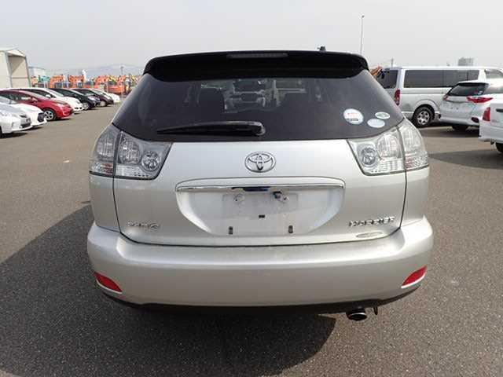

LANDCRUISER PRADO95 TX
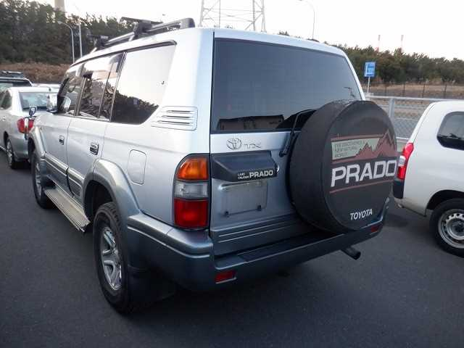

Toyota HILUX
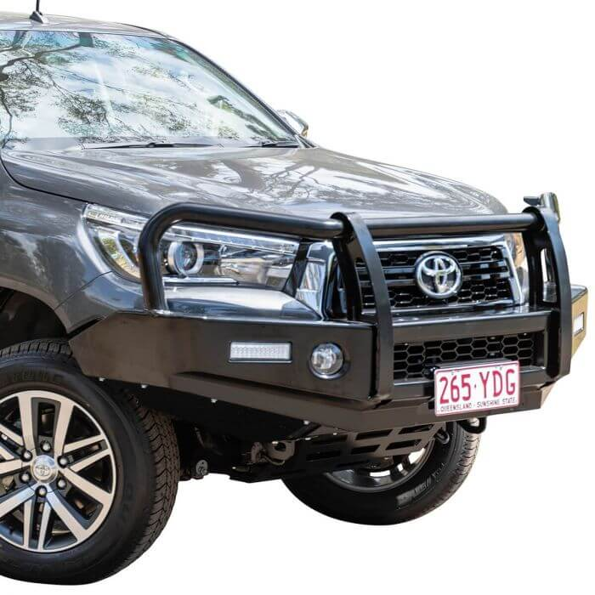

Toyota PRADO-150
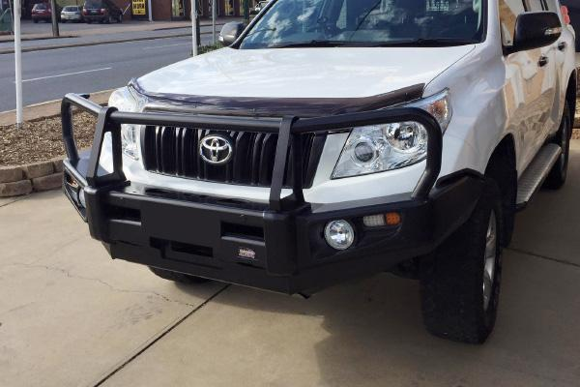

Toyota LAND CRUISER 70 HARD TOP
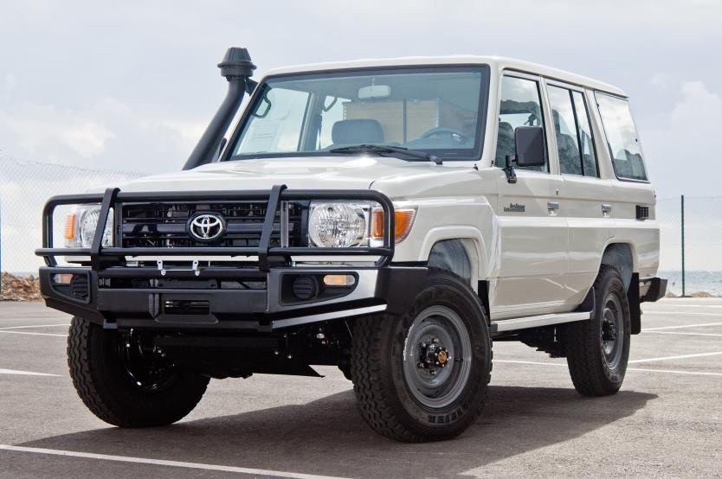

LANDCRUISER PRADO120 (RONALDO)
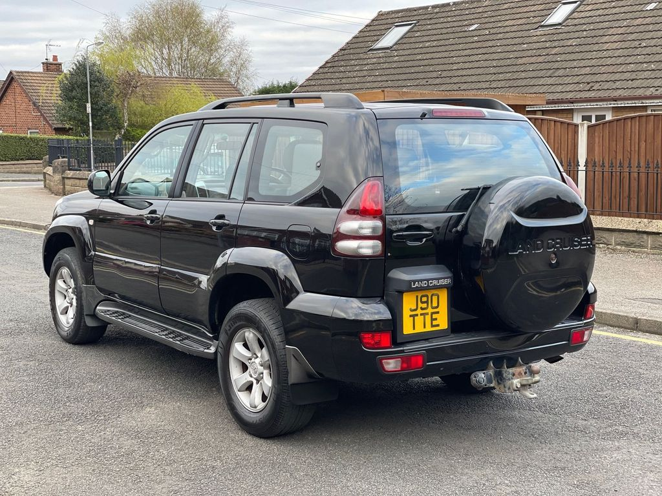

HIACE (DRONE)
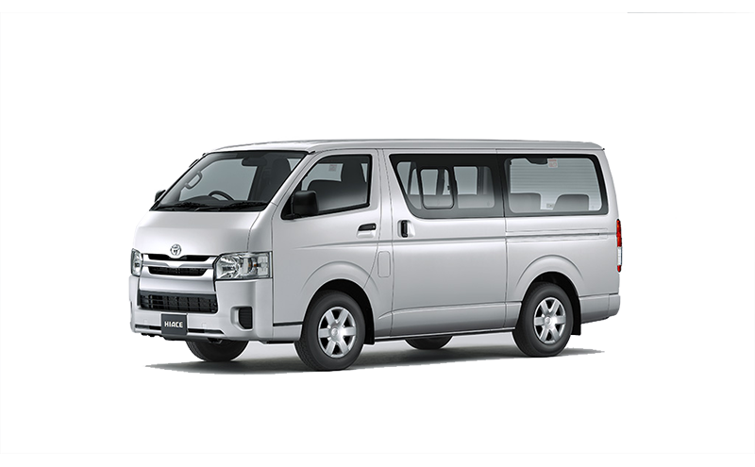

ISUZU BUS MV123 (6SD1)
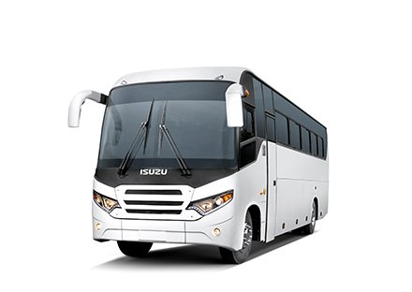

WISH
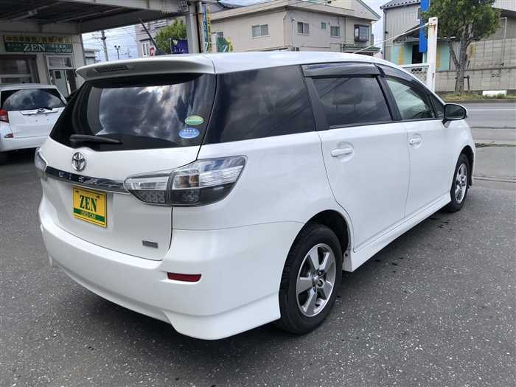

PREMIO
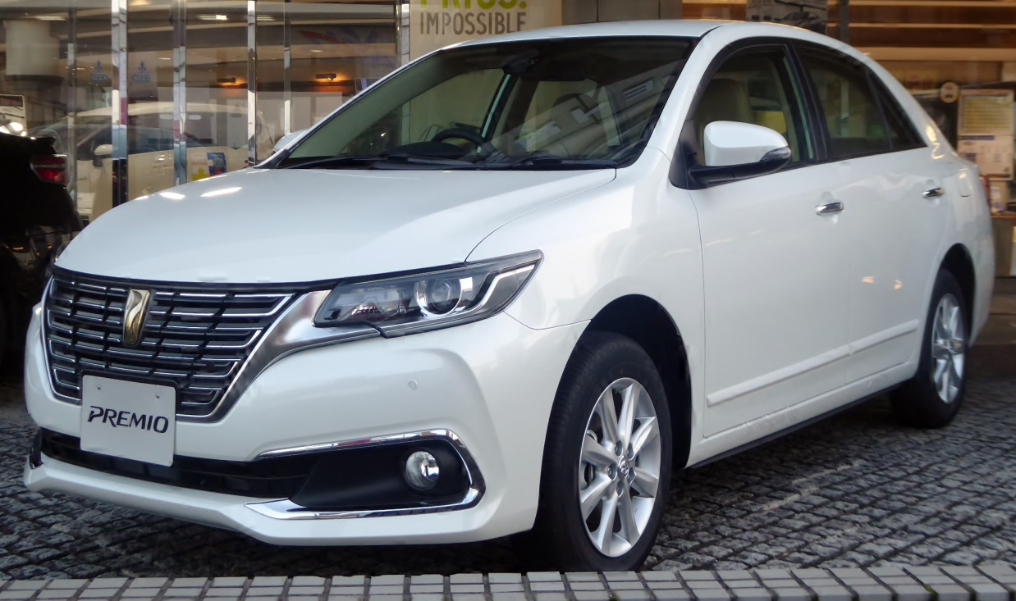

GENUINE PARTS FOR:
RAUM – SPACIO – SPACIO – FIELDER – IST – RUNX – ALLEX – NOAH
MARK X – VITZ – YARIS
ISUZU MV123

- VEHICLE ACCESSORIES
Toyota HILUX Tray / Bed Liners
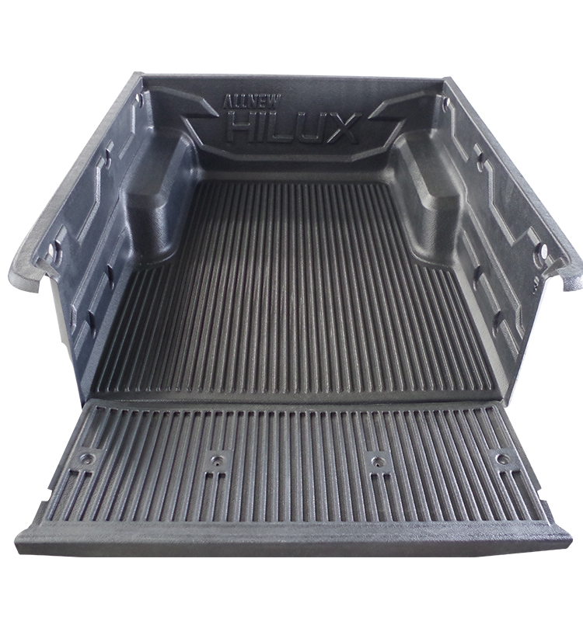

SIDE STEPS BULLBARS
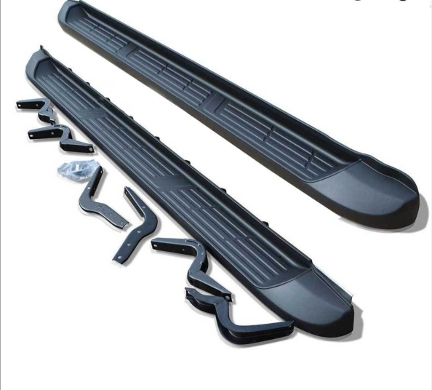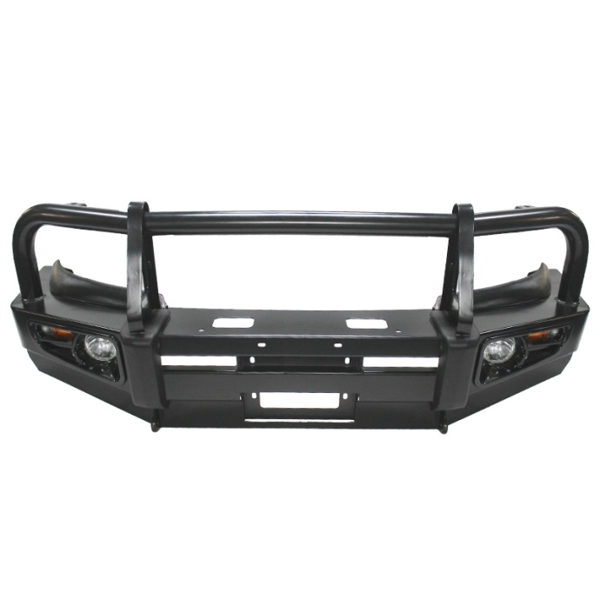

TONNEAU COVERS
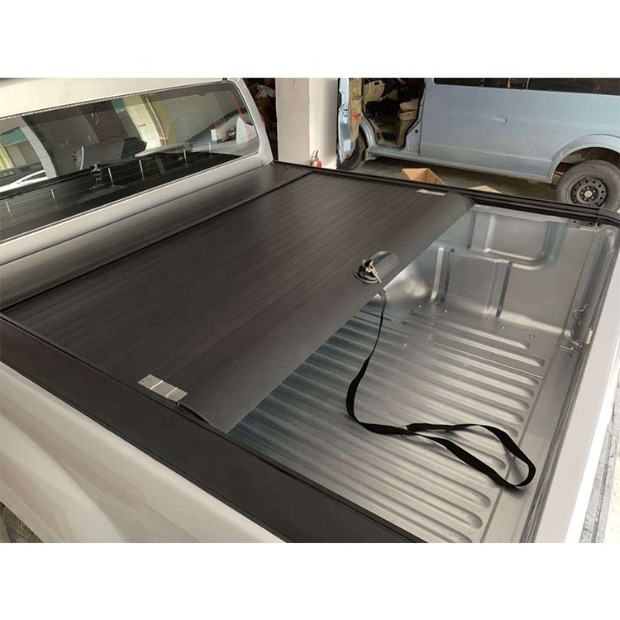
ROLLBARS
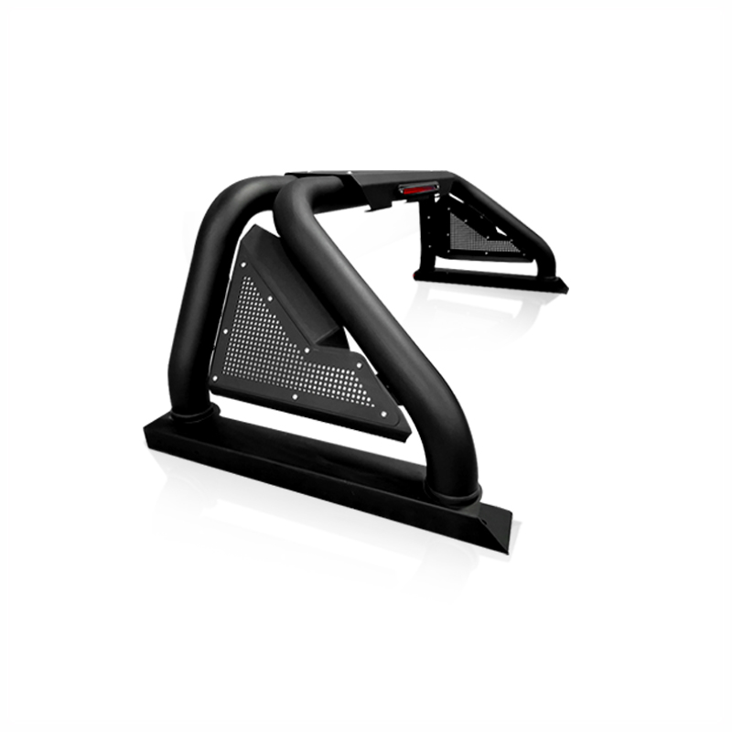

- Motorcycle Riding Gear
Gloves Knee & Elbow Pads RIDING Knee & Elbow Pads
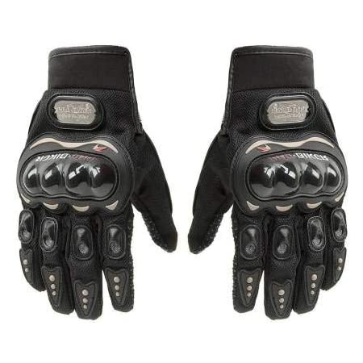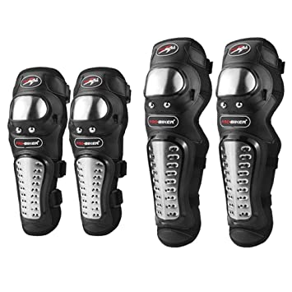
RIDING HELMETS RIDING SUITS
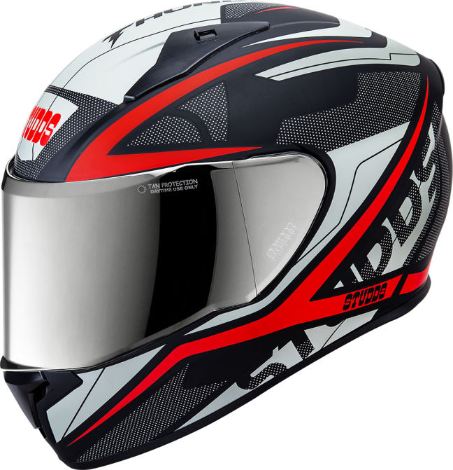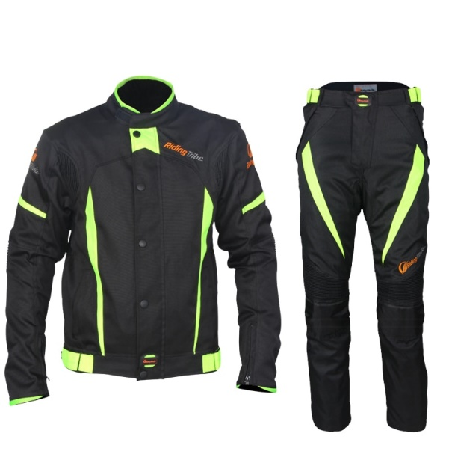

RIDING BOOTS GOLDEN BOY MOTORCYCLE TYRES 4.10X18, 2.75X21
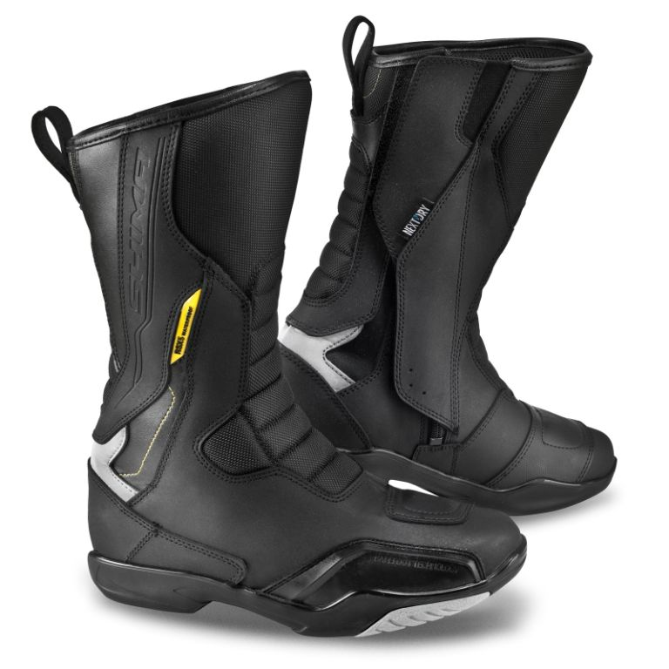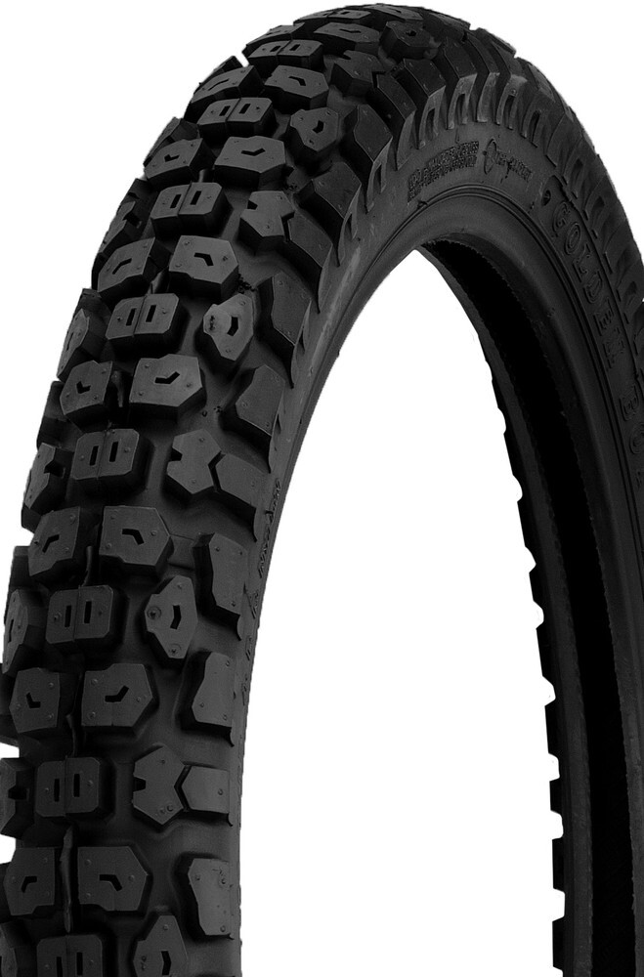

RIDING GEAR
